**Creating Microservices for account and loan**

### 1. Account Microservice

**Package:** **com.cognizant.account**

**Code:**

package com**.**cognizant**.**account**;**importorg**.**springframework**.**web**.**bind**.**annotation**.**GetMapping**;**importorg**.**springframework**.**web**.**bind**.**annotation**.**PathVariable**;**importorg**.**springframework**.**web**.**bind**.**annotation**.**RestController**;**importjava**.**util**.**HashMap**;**importjava**.**util**.**Map**;**@RestController  
public class AccountController {  
  
 @GetMapping("/accounts/{number}")  
 public Map<String, Object> getAccountDetails(@PathVariable String number) {  
 Map<String, Object> accountDetails = new HashMap<>();  
 accountDetails.put("number", number);  
 accountDetails.put("type", "savings");  
 accountDetails.put("balance", 234343);  
  
 return accountDetails;  
 }  
}

**application.properties:**

server.port=8080

**Output:**

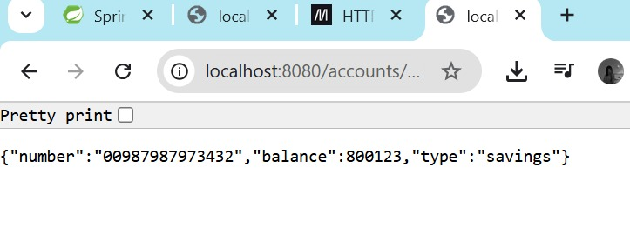

### 2. Loan Microservice

**Package:** com.cognizant.loan

**Code:**

package com**.**cognizant**.**loan**;**importorg**.**springframework**.**web**.**bind**.**annotation**.**GetMapping**;**importorg**.**springframework**.**web**.**bind**.**annotation**.**PathVariable**;**importorg**.**springframework**.**web**.**bind**.**annotation**.**RestController**;**importjava**.**util**.**HashMap**;**importjava**.**util**.**Map**;**  
  
@RestController  
public class LoanController {

number  
 @GetMapping("/loans/{number}")  
 public Map<String, Object> getLoanDetails(@PathVariable String number) {  
   
 Map<String, Object> loanDetails = new HashMap<>();  
 loanDetails.put("number", number);  
 loanDetails.put("type", "car");  
 loanDetails.put("loan", 400000);  
 loanDetails.put("emi", 3258);  
 loanDetails.put("tenure", 18);  
  
 return loanDetails;  
 }  
}

**application.properties:**

server.port=8081

**Output:**

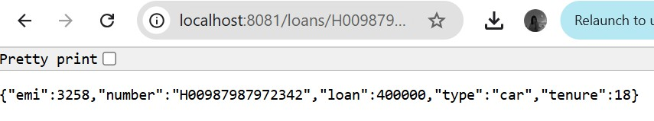

**OUTPUT (account) :-**

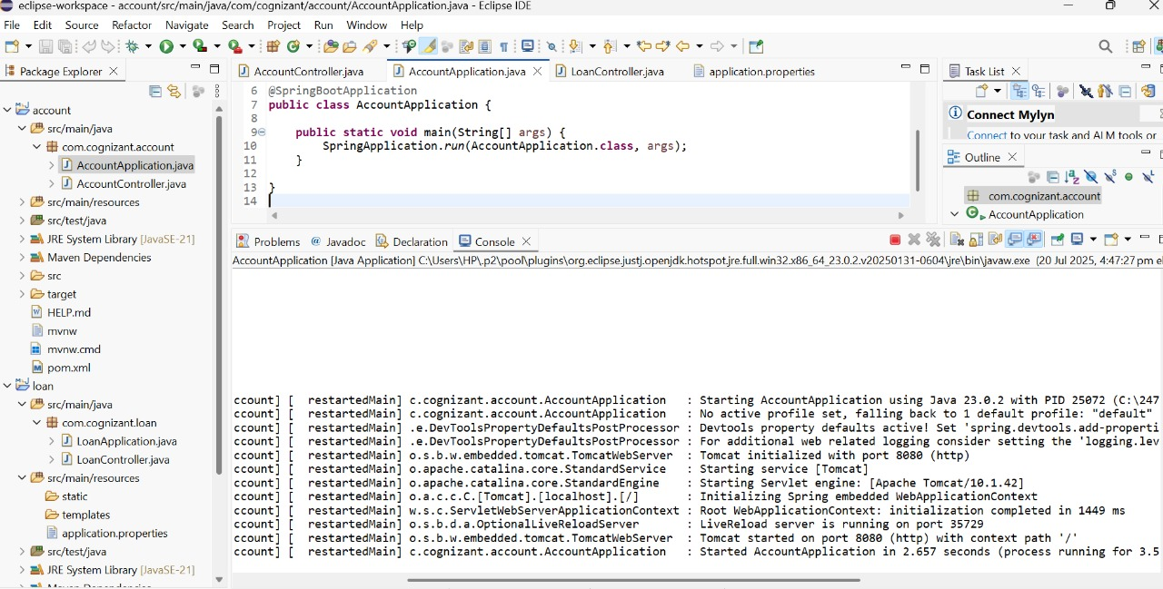

**OUTPUT (loan) :-**

